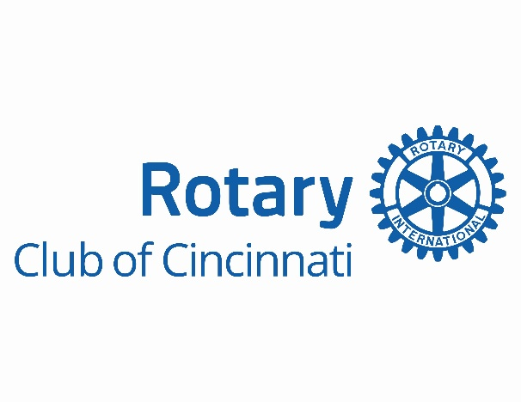
Job Title: Membership Growth & Marketing Strategist
Reports To: Executive Director
Part-Time | Hybrid – Greater Cincinnati Area
About the Rotary Club of Cincinnati
As one of Rotary International’s most prominent and historic clubs, the Rotary Club of Cincinnati is a thriving community of business, civic, and nonprofit leaders committed to Service Above Self. With over a century of impact, our Club continues to evolve to meet the changing needs of our members and the Greater Cincinnati community. As we grow and strengthen our Club, we simultaneously strengthen our Foundation creating a powerful engine for increased service, leadership development, and community impact.
Position Summary
The Rotary Club of Cincinnati seeks a dynamic and execution-focused Membership Growth & Marketing Strategist to lead targeted outreach, marketing initiatives, and member acquisition efforts. This new functional role is essential to our long-term strategy for sustainable growth, providing consistency and momentum year after year regardless of changes in Club leadership or committee involvement.
This position plays a vital role in expanding our impact. By driving member growth and visibility, this role directly supports the continued vitality of both the Club and our Foundation. It also enables the Executive Director to dedicate more time to high-level public relations, corporate partnership development, and increasing our visibility and brand awareness across the region.

Key Responsibilities
Prospecting & Member Acquisition
This is the core responsibility of the position. The success of this role is measured by its ability to consistently drive qualified leads, convert prospects into members, and strengthen the Club’s overall growth trajectory.
- Own and manage the full membership acquisition funnel from generating and qualifying leads to nurturing relationships and converting them into active, engaged members
- Execute high-volume outreach efforts by leveraging Club networks, curated prospect lists, and strategic partnerships to expand visibility and attract prospective members
- Serve as the primary point of contact for prospective members, ensuring timely, personalized follow-up and an exceptional first impression of our Club
- Actively support and promote Club events, programs, and campaigns as opportunities for prospect engagement, member onboarding, and long-term retention
- Collaborate with the Executive Director and Growth Committee to refine lead strategies and continuously improve the recruitment experience
Marketing & Outreach Execution
- Create and implement marketing campaigns (email, social, and promotional content) in alignment with the Club’s sales & marketing plan
- Collaborate with committees as outlined in the sales & marketing plan to develop, create, and distribute messaging, collateral, and creative that reflects Rotary’s mission and engages today’s diverse leaders
- Maintain the Club’s public image, storytelling, and visibility initiatives
- Lead and manage all social media, content creation, and daily execution in alignment with the sales & marketing plan and Club’s needs
Strategic Collaboration & Reporting
- Partner with the Club President, Executive Director, and Marketing & Communication Growth Committee leadership to align outreach and engagement initiatives
- Attend weekly Club meetings and monthly committee meetings
- Deliver monthly reports with KPIs such as leads generated, conversions, and campaign results
Qualifications
- 3+ years of experience in marketing, communications, or business development (nonprofit or civic sector preferred)
- Demonstrated experience in lead generation, campaign execution, or membership/recruitment efforts
- Strong communication skills (written, verbal, and interpersonal)
- Self-starter with excellent organizational and follow-up abilities
- Comfortable working independently and collaboratively within a committee-driven environment
- Familiarity with CRM, social media platforms, and digital marketing tools preferred
Equal Opportunity Employer
The Rotary Club of Cincinnati is an Equal Opportunity Employer. We value diversity and inclusion in all our endeavors and decisions and do not discriminate based on race, color, religion, sex, national origin, age, disability, veteran status, sexual orientation, gender identity, or any other protected class. We are committed to providing reasonable accommodations to qualified individuals with disabilities under the Americans with Disabilities Act (ADA).

